Subject: Algebra – Math A
Benchmark: Hatshepsut’s Temple
Standards: 3C, 3D, 7

TOPIC: Simplifying Radicals

MAJOR IDEA:
A radical expression is in its simplest form when all three statements are true:
    - The expression under the radical sign has no perfect square factors other than 1.
    - The expression under the radical sign does not contain a fraction.
    - The denominator does not contain a radical expression.
The multiplication property of square roots states that for any numbers a ≥ 0 and b ≥0, √ab = √a * √b
The division property of square roots states that for any numbers a ≥ 0 and b > 0, √ (a/b) = (√a) / (√b)

SUGGESTED AIMS:
How do we understand the conditions in which a radical expression is considered to be in its simplest form? Can you recognize when these conditions are met?
Can you reduce a radical expression, which is not in simplest form, into simplest form, utilizing the multiplication and division properties of square roots?

VISUAL EXAMPLES:
Picture of the Hatshepsut’s Temple:

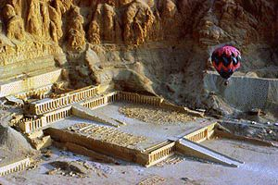

SUGGESTED ACTIVITIES:
Ponder the following: Why is simplification necessary?
Radicals that need simplification exist just about everywhere there is a square root sign. Imagine you are an archaeologist traveling from Cairo to the Temple of Hapshetsut at Deir El-Bahari. Using the map below and the distances provided, use the Pythagorean Theorem to calculate the distance in simplified radical form. The number is very large, so look for big perfect-square factors initially. (The easiest way to factor the distance is 100 * 64 * 17).

Calculate the distance that you must hoist your archaeological equipment up the temple ramp. Using the dimensions of the ramp below, use the Pythagorean Theorem to calculate the length of the hypotenuse, making sure that your answer is in simplest radical form.

RESOURCES:
http://www.ehabweb.net/hatshebsut_temple.html Various views of the temple of Hapshepsut.
http://www.phxart.org/egypt_ed.html Educational site about Egypt; source of map.

HOMEWORK:
Simplify the following: √98, 4√36, 3√32, √40 * √90, √40320

